PO Box 1938,
52 N. First St., Granby, CO 80446
(970) 887-1177 info@coloradoheadwaterslandtrust.org
www.coloradoheadwaterslandtrust.org

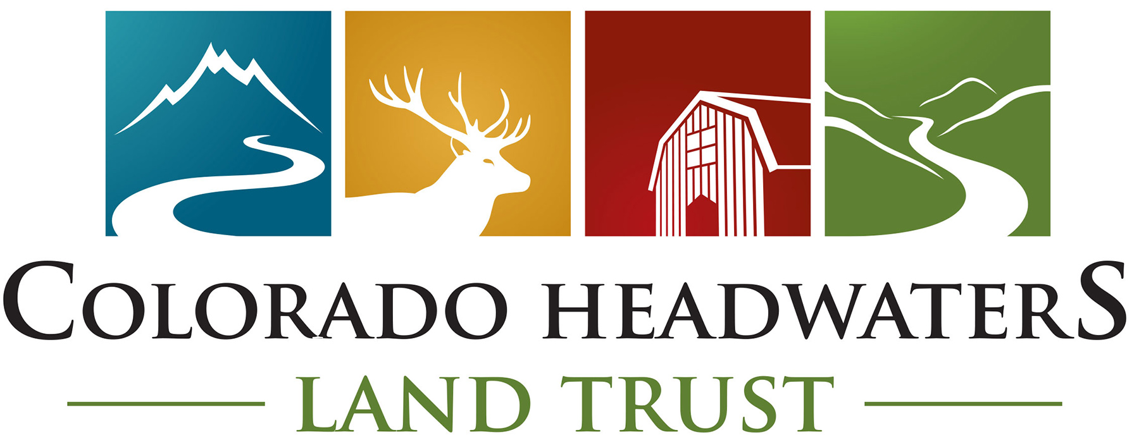

Conservation Partner Program Agreement for Small Business Owners

Date: ________________

Business Name: ______________________________________________________Owner’s name: _______________________________________________________

Mailing Address: _____________________________________________________Physical Address (Business): _______________________________________

Phone Number (Business): _________________________________________Cell: ______________________________________ _____________________________

Email Address: ______________________________________________________ Website: ______________________________________________________________

My accountant’s name and contact information is: _______________________________________________________________________________________

How will your business participate in the program?
⎕⎕1% voluntary contribution on customer’s gross sales before taxes (with capability for customers to opt out if they request)
⎕⎕$1 added to the total amount listed on customer’s receipt (with customers having the option to opt out)
⎕⎕Other: ______________________________________________________________________________________________________________________________________

_________________________________________________________________________________________________________________________________________________

How often will you send in your business’ donation checks to CHLT?
⎕⎕Monthly
⎕⎕Quarterly
⎕⎕Other: _____________________________

I am collecting donations from clients on:
⎕ All products and services
⎕ Products only
⎕ Services only
⎕ Other: _______________________________

Would you like a reminder to send in your donation? ⎕⎕ Yes ⎕⎕No

Does CHLT have your permission to print your business on our website, our electronic newsletter and newspaper advertisements regarding the Colorado Headwaters Land Trust and the Conservation Partner Program? ⎕⎕ Yes ⎕⎕No

Are you willing to mentor new program participants or act as a spokesperson for the program?
⎕⎕ Yes ⎕⎕No

TERMS:
_____ I agree to remit funds no later than 30 days after the month or quarter has finished.
_____ I agree to openly advertise (by placing a window static and brochure in two locations) my business’ participation in the Conservation Partner Program so that customers/clients are aware their purchases help support Colorado Headwaters Land Trust.
_____ I agree to provide notification of my business’ participation with the Conservation Partner Program on the customer’s receipt.

Signature: ______________________________________________________________ Date: ______________________________

